1. **Ideation**:

**Overview:** Our project aims to recommend movies based on user input or social connections.

Our ignition slide:

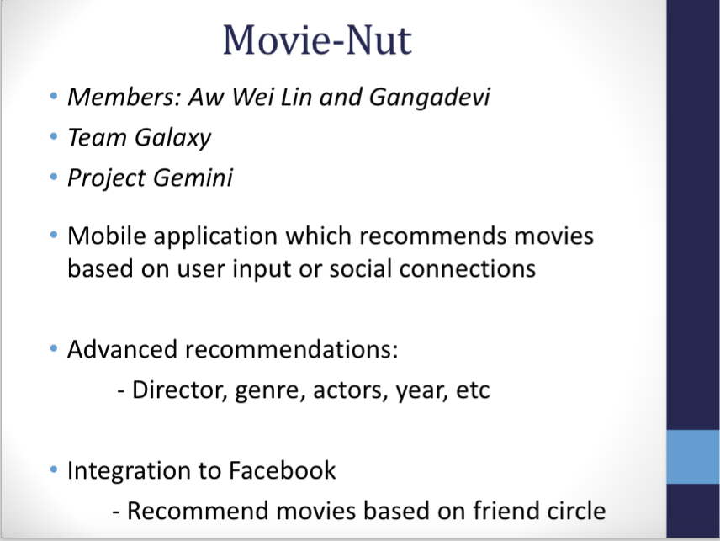

YouTube link to our Ignition presentation:  <https://youtu.be/osQjStOAci0?t=6926>

**2. Planned Features**:

1. **References:**
   1. References Used
   2. Software Installed
      1. Android Studio
      2. SourceTree
2. **Time Spent**

|  |  |  |  |  |  |
| --- | --- | --- | --- | --- | --- |
| **S/N** | **What** | **Date** | **Ganga (Duration)** | **Wei Lin**  **(Duration)** | **Remarks** |
| 1 | Liftoff Day 1 | 11/05/2015 | 8 | 8 |  |
| 2 | Installing Git/ Android Studio / SourceTree | 11/05/2015 | 3 | 3 |  |
| 3 | Liftoff Day 2 | 12/05/2015 | 8 | 8 |  |
| 4 | Learning HTML/CSS | 12/05/2015 | 5 | 5 | Using Codecademy exercises |
| 5 | Learning Android Studio | 15/05/2015 | 5 | 5 | Using youtube video and google search |
| 6 | Creating User Stories | 20/05/2015 | 4 | 4 | Discussed together in Central Library |
|  |  |  |  |  |  |
|  | **Total Hours** |  |  |  |  |